1. How are inline and block elements different from each other?
The block elements take up the full size of the screen from left to right and each block level element starts on a new line.
Inline elements only take up the width required by the content in them. They do not strecth throughout the parent, also inline elements does not start from new line.
For e.g. - The <div> element is a block-level element.
The <span> element is an inline-level element.
2.Explain the difference between visibility:hidden and display:none
visibility:hidden hides the element, but it still takes up space in the layout.
display:none removes the element from the document. It does not take up any space

3. Explain the clear and float properties.
The float property is used for positioning and formatting content e.g. let an image float left to the text in a container.
The float property can have one of the following values:
- left - The element floats to the left of its container
- right - The element floats to the right of its container
- none - The element does not float (will be displayed just where it occurs in the text). This is default
- inherit - The element inherits the float value of its parent
In its simplest use, the float property can be used to wrap text around images.
The clear property specifies what elements can float beside the cleared element and on which side.
The clear property can have one of the following values:
- none - Allows floating elements on both sides. This is default
- left - No floating elements allowed on the left side
- right- No floating elements allowed on the right side
- both - No floating elements allowed on either the left or the right side
- inherit - The element inherits the clear value of its parent
The most common way to use the clear property is after you have used a float property on an element.

4. Explain difference between absolute, relative,fixed and static.

position: static
HTML elements are positioned static by default. Static positioned elements are not affected by the top, bottom, left, and right properties. An element with position: static; is not positioned in any special way; it is always positioned according to the normal flow of the page.
position: relative
An element with position: relative; is positioned relative to its normal position. Setting the top, right, bottom, and left properties of a relatively-positioned element will cause it to be adjusted away from its normal position. Other content will not be adjusted to fit into any gap left by the element.

position: fixed
An element with position: fixed; is positioned relative to the viewport, which means it always stays in the same place even if the page is scrolled. The top, right, bottom, and left properties are used to position the element. A fixed element does not leave a gap in the page where it would normally have been located.

position: absolute
An element with position: absolute; is positioned relative to the nearest positioned ancestor (instead of positioned relative to the viewport, like fixed). However; if an absolute positioned element has no positioned ancestors, it uses the document body, and moves along with page scrolling.

5. Write the HTML code to create a table in which there are 4 columns( ID , Employee Name, Designation, Department) and at least 6 rows. Also do some styling to it.
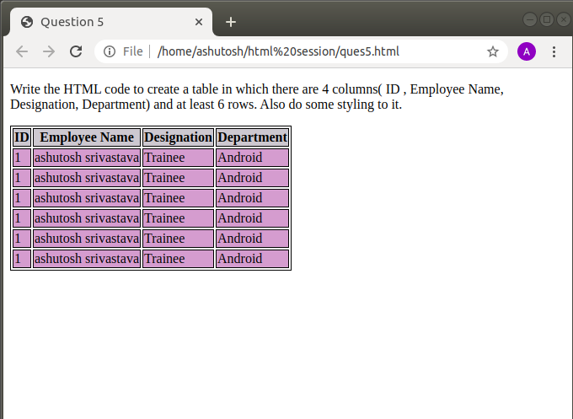

6. Why do we use meta tags?
Meta tags provide the meta data to the html document which is readable by machine but is not visible. Meta elements are typically used to specify page description, keywords, author of the document, last modified, and other metadata. Also, it helps to improve the SEO( Search Engine Optimization) of a web page by using certain keywords related to the web page.

7. Explain box model.
All HTML elements can be considered as boxes. In CSS, the term "box model" is used when talking about design and layout.
The CSS box model is essentially a box that wraps around every HTML element. It consists of: margins, borders, padding, and the actual content. The image below illustrates the box model:
Explanation of the different parts:
- Content - The content of the box, where text and images appear
- Padding - Clears an area around the content. The padding is transparent
- Border - A border that goes around the padding and content
- Margin - Clears an area outside the border. The margin is transparent
The box model allows us to add a border around elements, and to define space between elements.
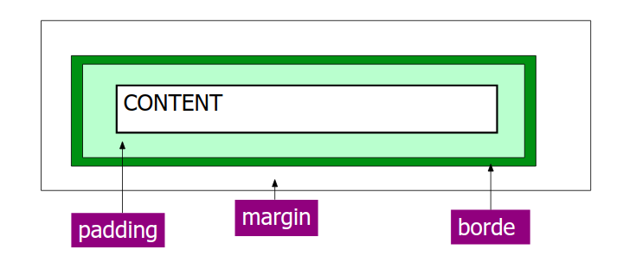
8. What are the different types of CSS Selectors?
In CSS, selectors are patterns used to select the element(s) to be styled.
Syntax: selector { property: value }
example:
body {background: #eeeeee; font-family: Georgia, sans-serif;}
h1 {font-family: Georgia, sans-serif;}
h1, h2 {color: #009900;font-family: Georgia, sans-serif;}

9. Define Doctype.
A Document Type Declaration, or DOCTYPE for short, is an instruction to the web browser about the version of markup language in which a web page is written. A DOCTYPE declaration appears at the top of a web page before all other elements.
10. Explain 5 HTML5 semantic tags.
HTML5 is the latest version of HTML and it introduces many new <tags> and features.
Some of the commonly used new tags of HTML5 are :
<article> - Defines an article in the document
<aside> - Defines content aside from the page content like sidebar.
<footer> - Defines a footer for the document or a section
<header> - Defines a header for the document or a section
<nav> - Defines navigation links in the document
<section> - Defines a section in the document

11. Create HTML for web-page.jpg (check resources, highest weightage for answers)
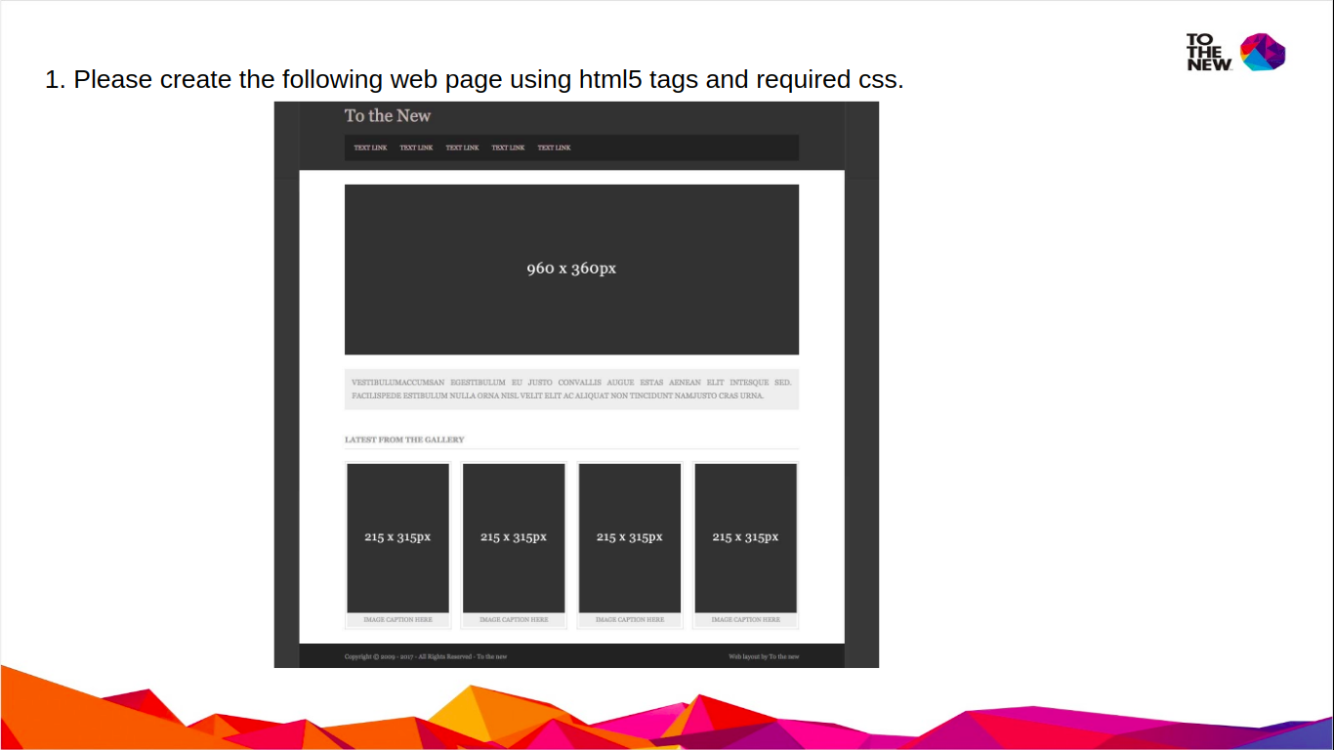
Answer: screeen shot in 2 parts
code attached with file name
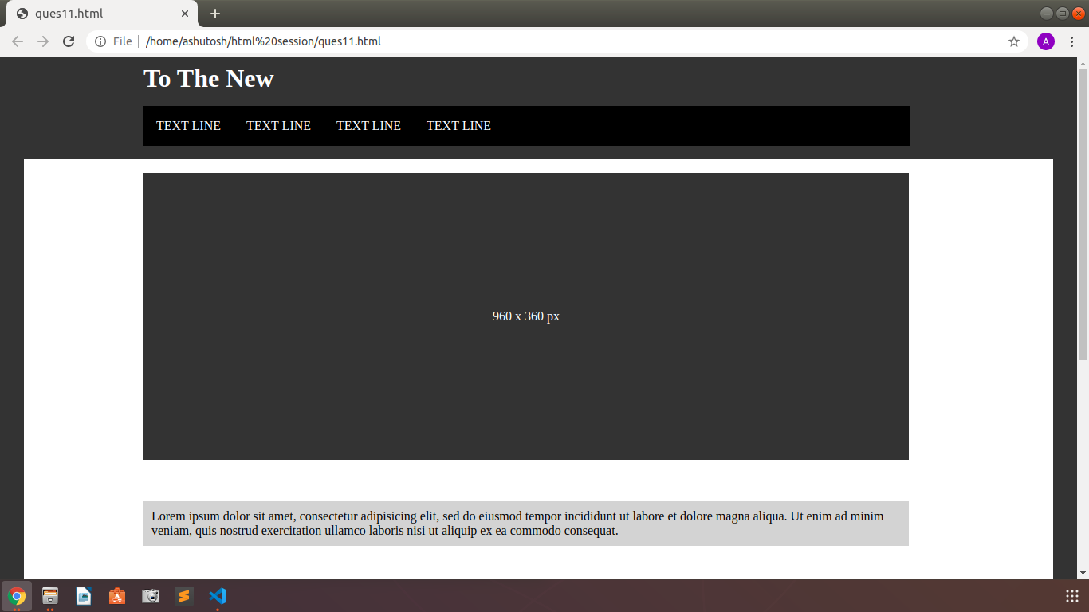
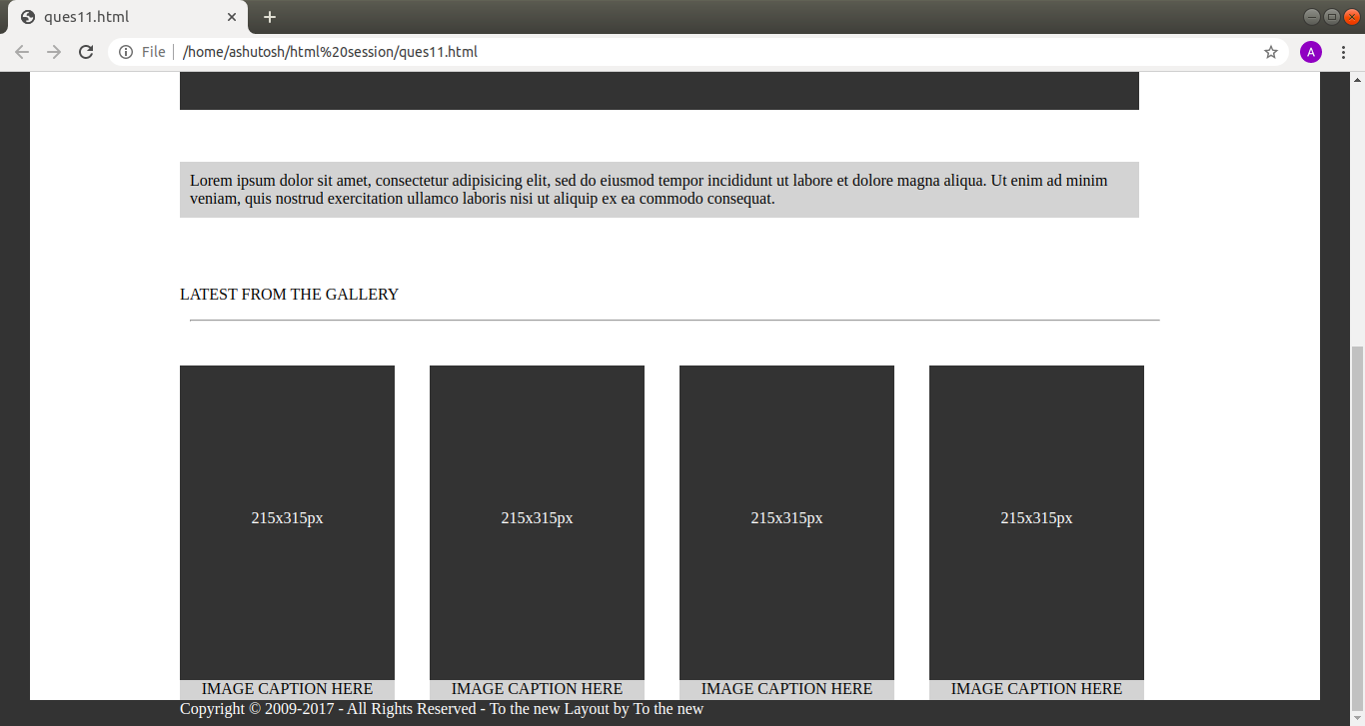

12. Create HTML for form.png (check resources, highest weightage for answers)
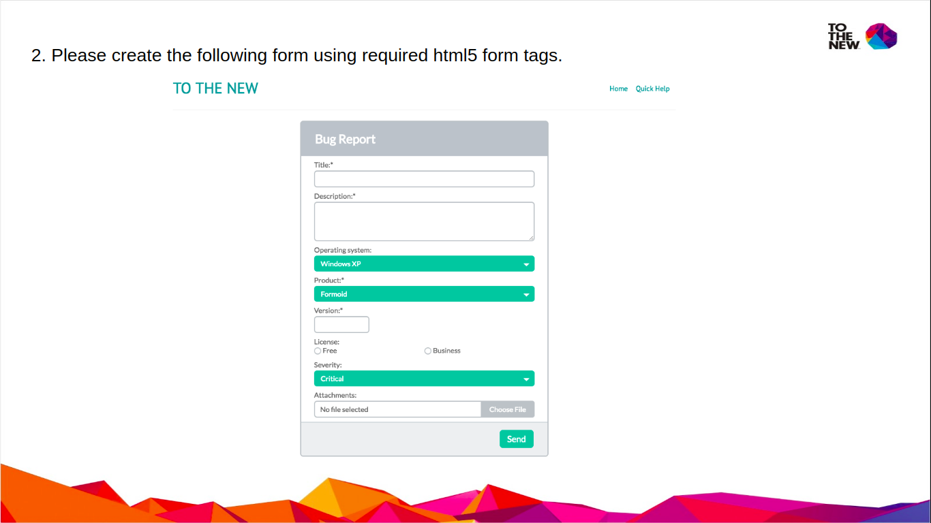
Answer
Code attached with file name
